How to update my local machine from Github

Go to command prompt

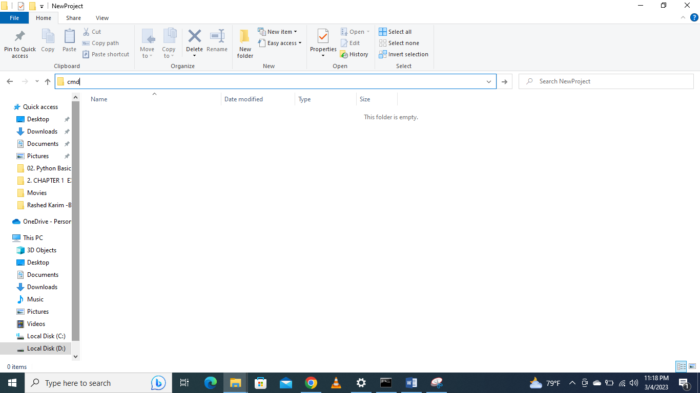

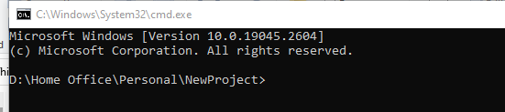

Write git pull



File new file downloaded in your local machine

